

**Name Bhuvana K**

**Department CSE**

**Set up a git branching**

ABOUT:

Creating a new branch in a GitHub repository is a common practice in software development to test or add new features without impacting the main codebase. By isolating changes in a

separate branch, developers can experiment, review, and validate the modifications before merging them into the main branch.

SIGNIFICANCE:

1. Code Isolation: Ensures changes are isolated, minimizing the risk of breaking the main branch or affecting existing functionality.
2. Parallel Development: Allows multiple developers or teams to work on different features

simultaneously without interfering with each other's work.

1. Emcient Testing: Features can be tested thoroughly in a dedicated environment, ensuring quality before integration.
2. Conflict Resolution: Makes resolving merge conflicts easier and localized to specific features

STEP 1:

Create a folder with files open cmd promt copy the folder

Step 2:

Initialize git - git init

git . folder will be created into your local folder which will record all the files in your folder



# STEP 3:

Type the following command to create a new file into your empty repository



# STEP 4:

Add the file to your git repository and keep track your file’s activity



# STEP 5

Commit the files inside your folder to git using the command: git commit -m “message”

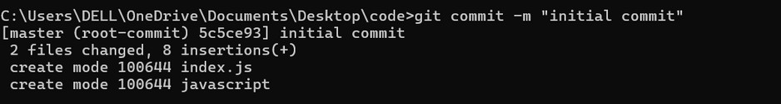

# STEP 6:

switch to a new branch



# STEP 7:

add a file to the feature and stage the content



# STEP 8

commit the content change

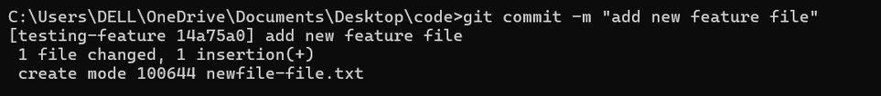

# STEP 9

Go to master branch



# STEP 10

follow the command and merge changes to master branch

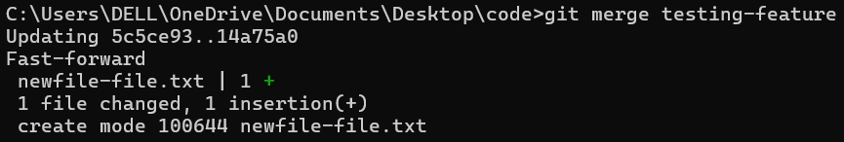

# STEP 11

delete the merged branch



# STEP 12

flles are copied inside folder

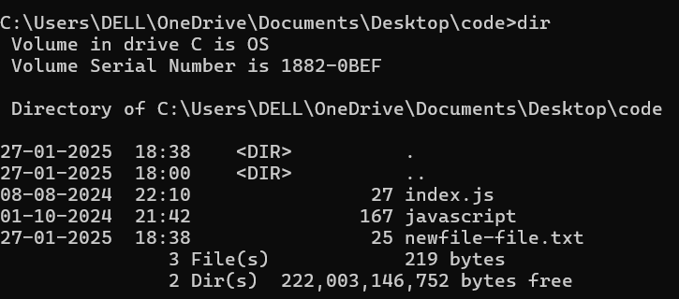

Outcomes:

1. A new branch (feature/test-branch) is created and used for testing or adding new features.
2. The changes are safely merged into the main branch without disrupting the production codebase.
3. Emcient collaboration and code management through Git’s branching and

merging workflows.